This folder includes the project we used to run gamma correction in Unity.

The “GammaCorrection” project is created to test whether the gamma correction is correctly conducted. You should have already created the LUT texture through MATLAB in advance. Import the created the texture (default location: Gamma Correction for VR display/MATLAB related/Saved texture files) into the project.

Select the imported texture, and do some revisions about the property.

Click the “Read/Write Enabled”, unclick the “Generate Mip Maps”, and set the ”Compression” into “None” in the Inspector window.

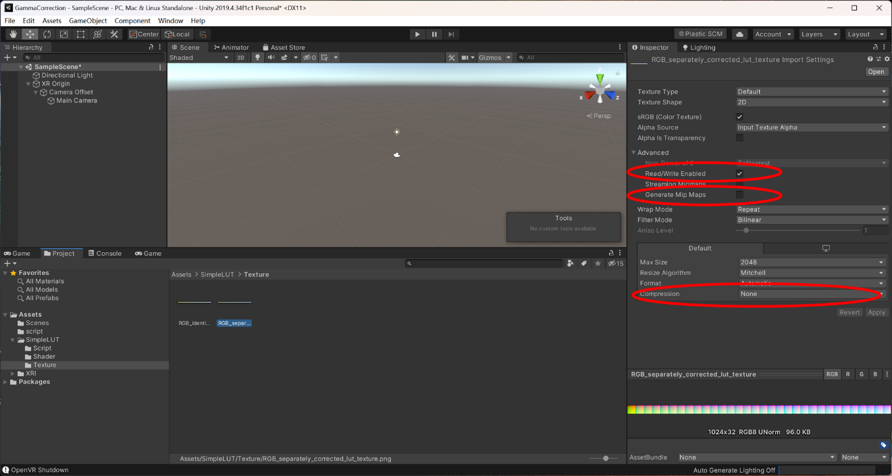

You should drag your texture into the “Lookup Texture” in the Inspector window. If you do not want to conduct the correction, you can keep the “None” unchanged. This is useful when you want to create your texture.

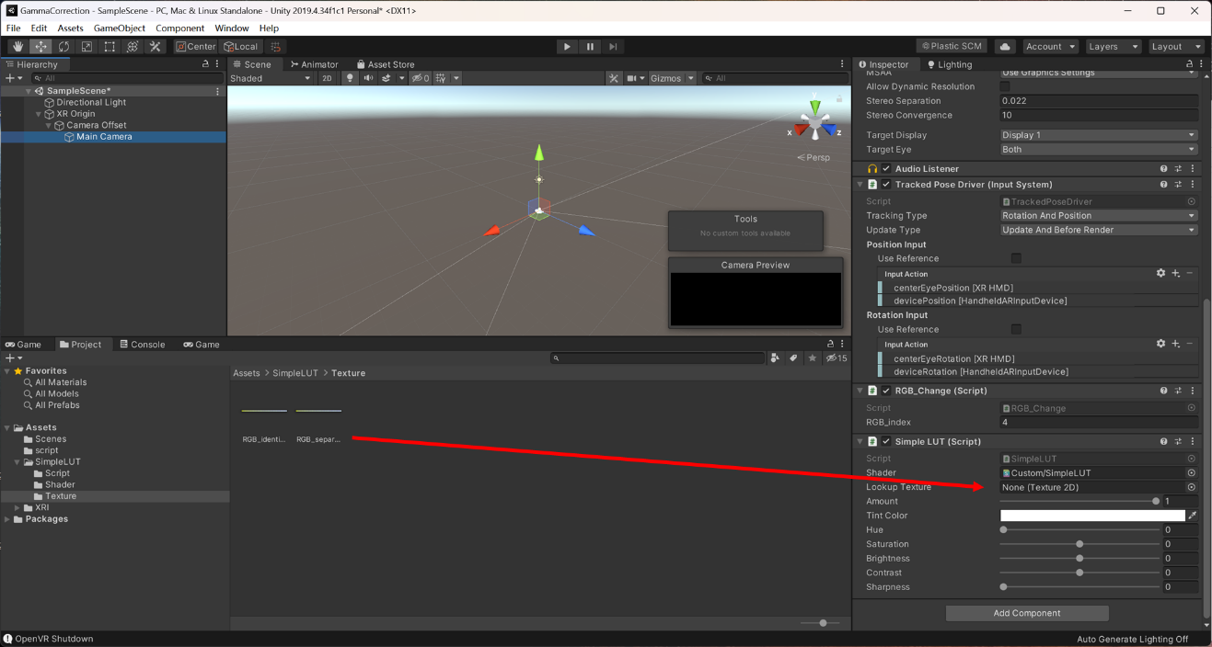

You can set the “RGB_index” in the “RGB_Change” script. A value of 1 indicate to present the red stimulus (R channel) during the experiment; a value of 2: green stimulus (G channel); a value of 3: blue stimulus (B channel); a value of 4: achromatic stimulus (RGB channels).

Please note that the SimpleLUT asset has been imported with deleting irrelevant parts. If you are interested in the original SimpleLUT asset, please download and re-import the asset. There are a lot of interesting features in SimpleLUT asset, please read them by yourself. You can download the asset through the following link.

<https://assetstore.unity.com/packages/vfx/shaders/fullscreen-camera-effects/simple-lut-adjuster-51762>

**Useful Tips:**

The color space mentioned in the paper can be seen by “Edit > Project Settings > Player > Other Settings > Rendering > Color Space”.

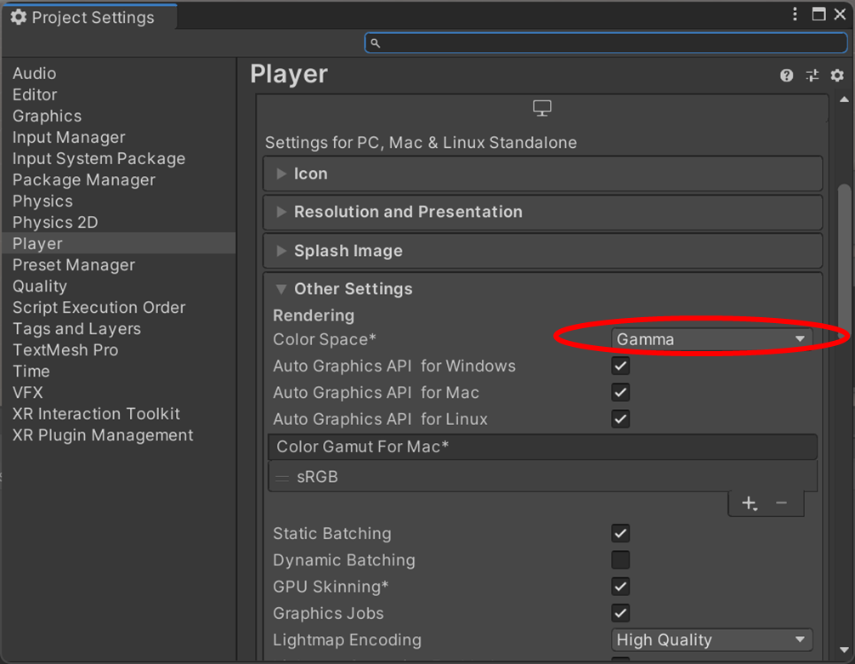

You may want to change the “Turn off displays after” setting into “5 MINUTES”. Otherwise, VR display would turn off if you do not wear the headset in “5 SECONDS”, which is the default setting. It can be very annoying when conducting the gamma correction in Unity by yourself.

